**Hotel Management**

* **Data URL:** <https://drive.google.com/drive/folder...0>
* **Data Fields:**

|  |  |
| --- | --- |
| **COLUMNS** | **DATATYPES** |
| Booking ID | Whole Number |
| Hotel | Text |
| Booking Date | Date |
| Arrival Date | Date |
| Lead Time | Whole Number |
| Nights | Whole Number |
| Guests | Whole Number |
| Distribution Channel | Whole Number |
| Customer Type | Whole Number |
| Country | Whole Number |
| Deposit Type | Whole Number |
| Avg Daily Rate | Decimal Number |
| Status | Text |
| Status Update | Date |
| Cancelled (0/1) | Whole Number |
| Revenue | Decimal Number |
| Revenue Loss | Decimal Number |

* **Column profile:**

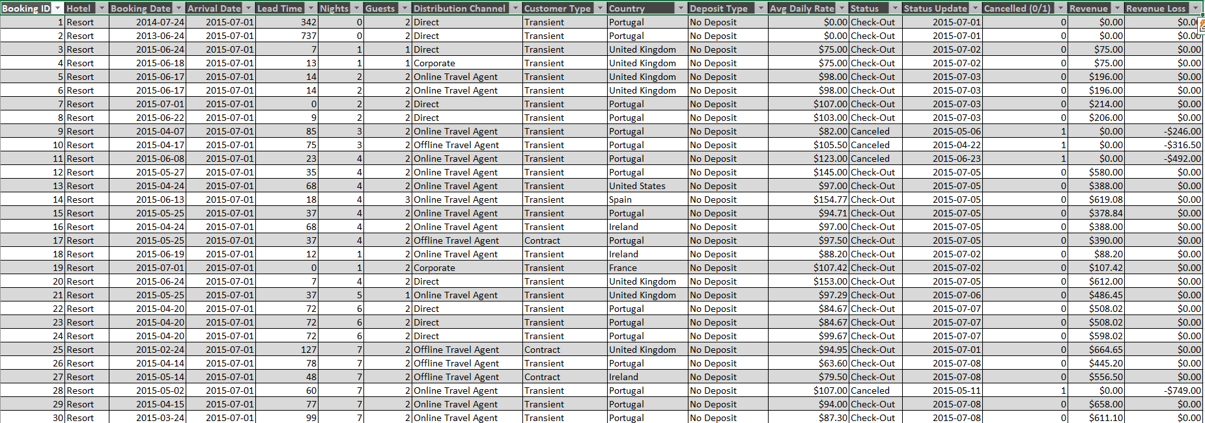

* **ERP Model:**

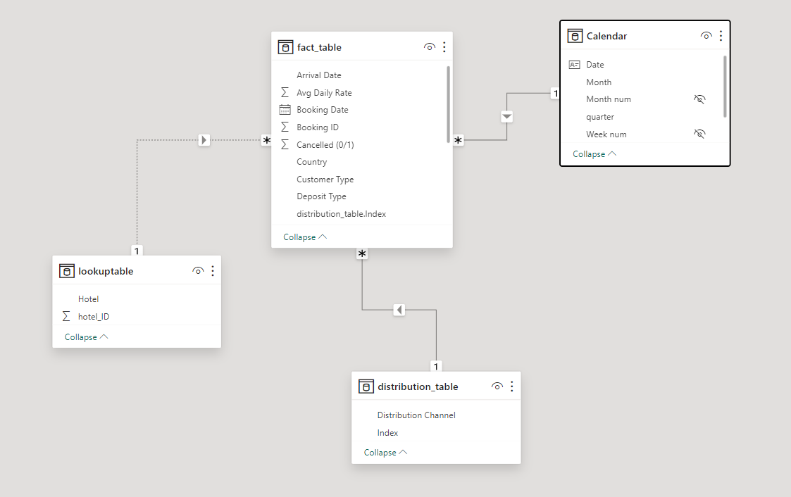

* **Power BI:**

**DATA:** Calender

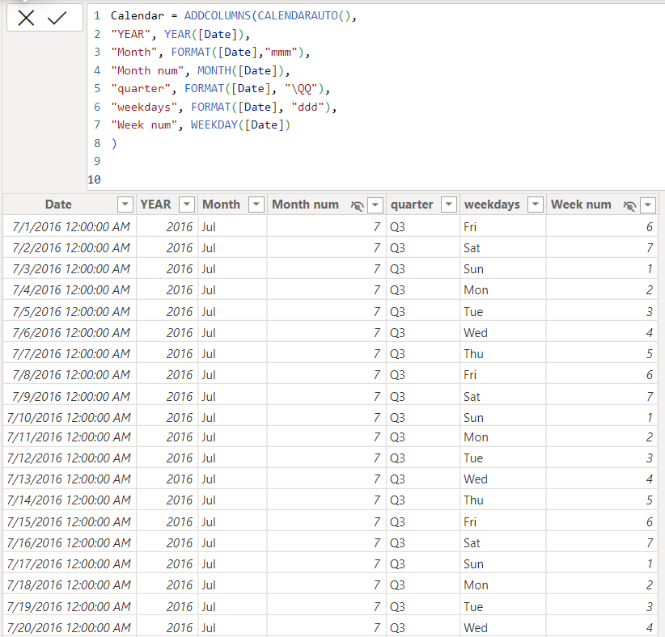

**Normalize Data**:

* Distribution_table

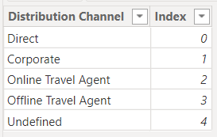

* Lookuptable

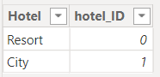

**Measures Query**:

* %_cancellation



* Avg_dailyRate



* Revenue_loss



* Total_cancellation

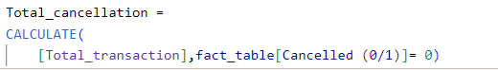

* Total_revenue



* Total_transaction



**Report View**:

* Total_Revenue and Revenue_Loss by Month

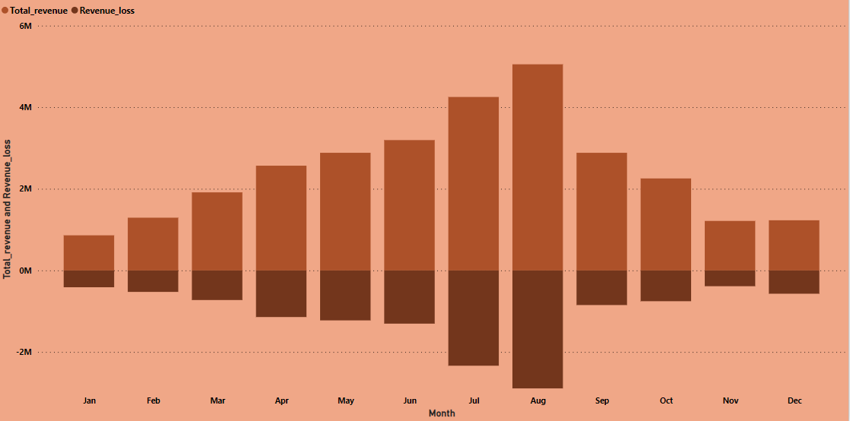

* Avg_DailyRate and %_Cancellation

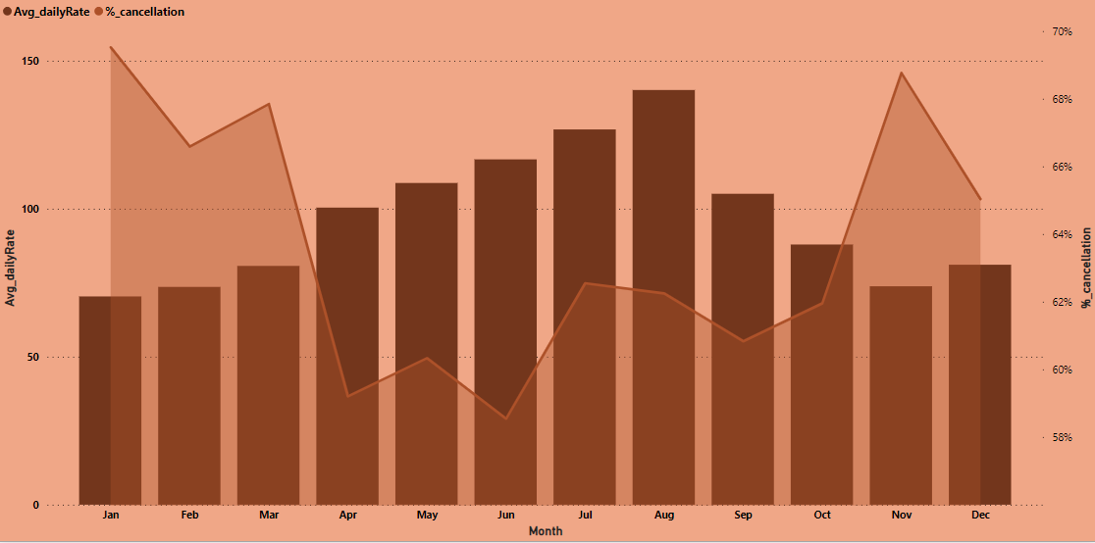

* Total_Cancellation by Weekdays

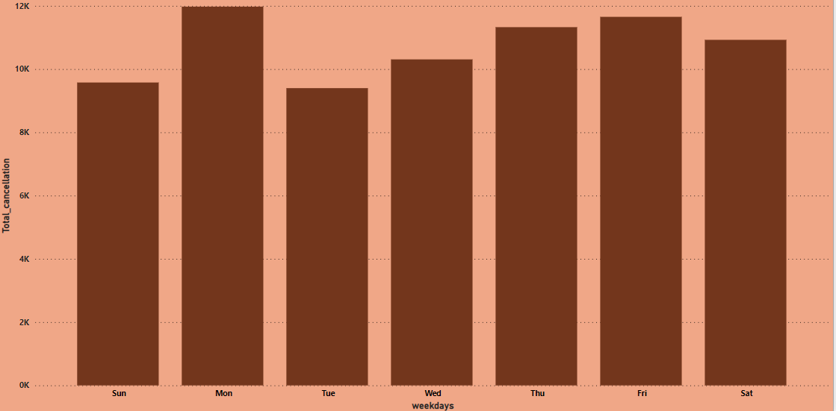

* %_Cancellation by Lead Time Transformed0

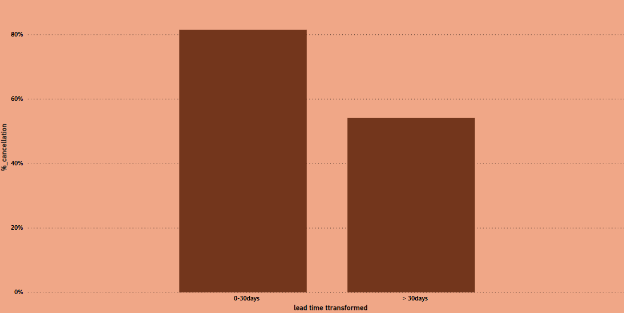

* Avg_DailyRate by Lead Time Transformed

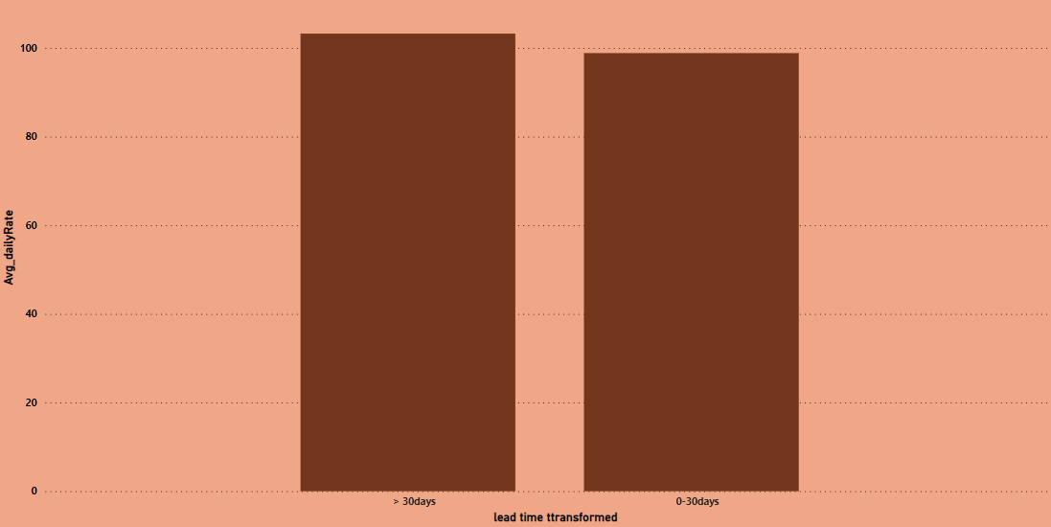

**DashBoard:**

